UberCARE — One-Pager
_______________________________________
Respite Care for Kin-Keepers. Companionship for Elders. Remote Work for Caregivers.
____________________________________________________________________________________
The Problem
Over million Americans provide unpaid care to an aging loved one. Most are working adults — daughters, sons, spouses — who are burning out. They cannot afford residential care ($ 90,000+/year), and their parents often refuse to leave home. Meanwhile, 14 million seniors live alone, and loneliness is now classified as a public health crisis equivalent to smoking 15 cigarettes a day.
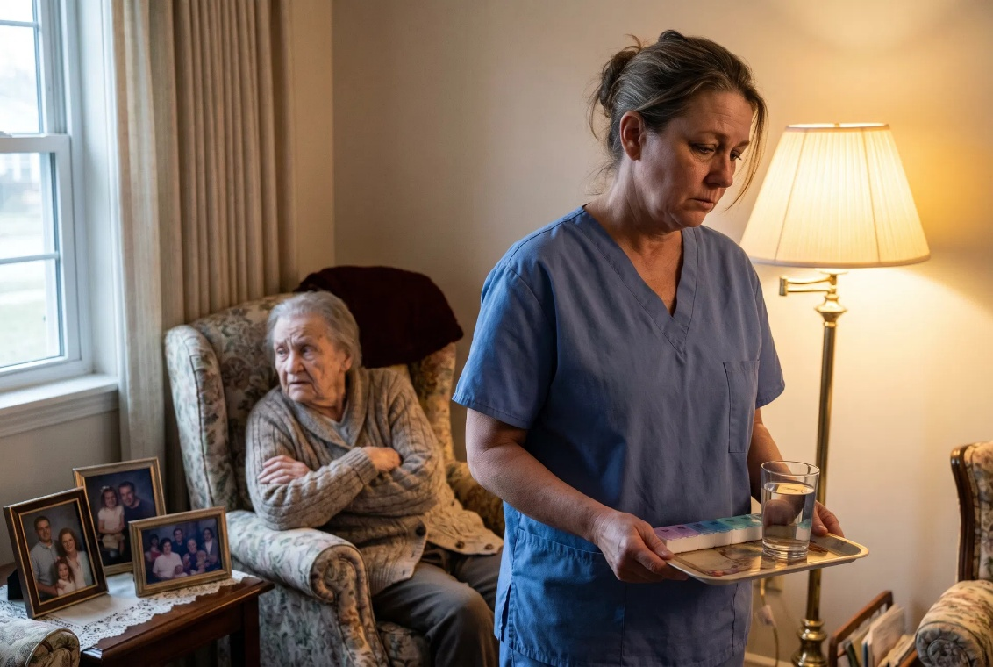
The Solution: UberCARE
UberCARE connects isolated elders with professional remote companions — through their existing TV. No smartphone. No app. No tech skills required.

A trained caregiver appears on the elder’s television screen for a scheduled session —
chatting, playing memory games, reading together, or simply being present. The
family member (the “Kin-Keeper”) books and manages sessions from their phone in
minutes.
AI Superpowers: There’s more. Caregivers not only bring skills and hours, but they also bring AI workers. These are tools that connect with Family Circle data in a private manner, and morph into elder knowledgeable assistants. Armed with these new superpowers, Caregivers can not only extend adaptive services to those they love, but also earn income while they sleep.

____________________________________________________________________________________

________________________________________________________
How It Works
Step | What Happens
1. Book | Kin-Keeper books a session via the UberCARE app (as easy as ordering a ride)
2. Connect | At the scheduled time, the caregiver appears on the elder’s TV screen
3. Companion | Real conversation, games, music, storytelling — 30 to 90 minutes
4. Recap | Kin-Keeper receives a session summary and wellbeing notes

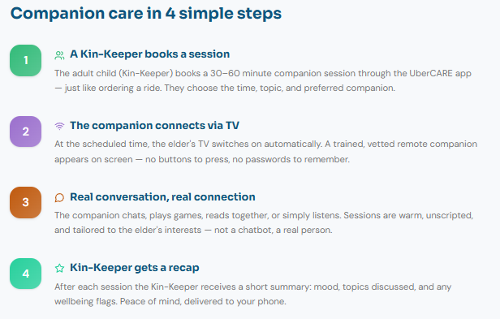

Why the TV?
________________________________________________________
Elders trust their TV. It requires zero new technology, no login, no touchscreen. The familiar screen removes the barrier that kills adoption of most elder-tech products.

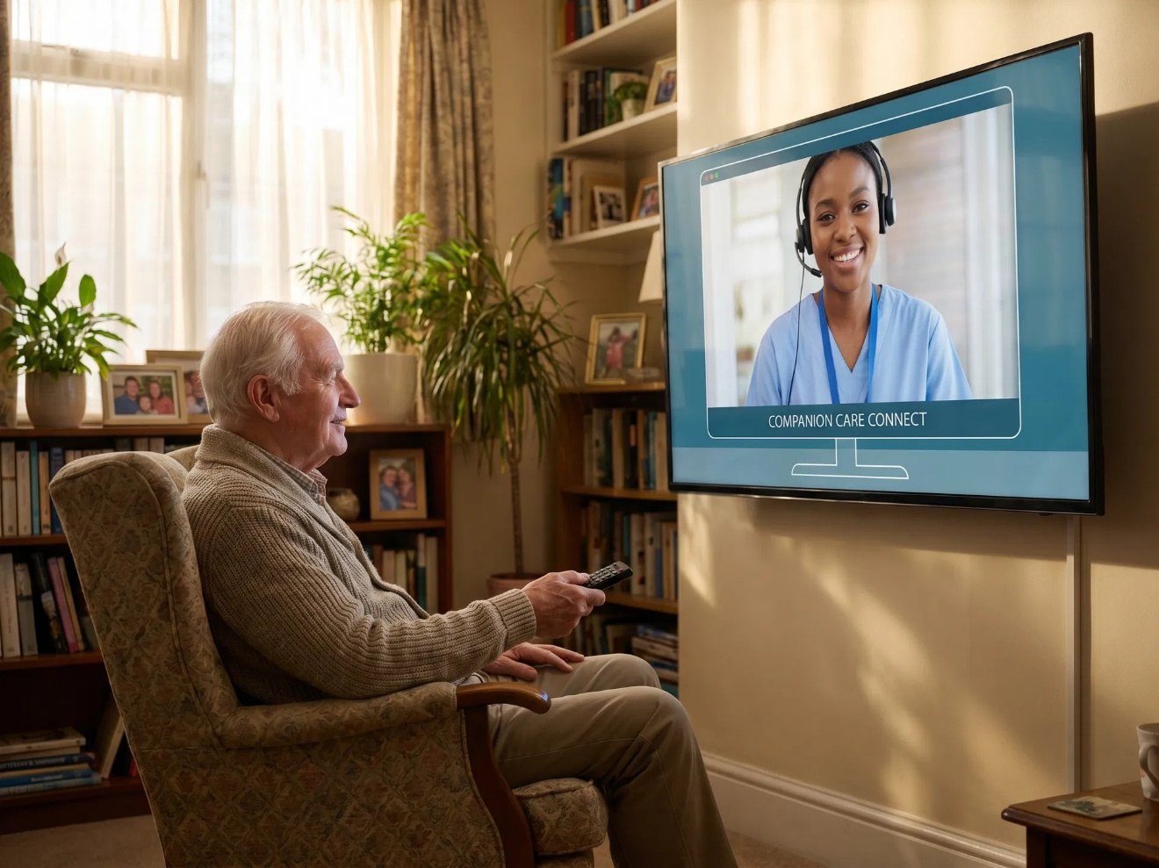

Who We Serve
________________________________________________________
Kin-Keepers — Adult children and spouses managing a parent’s care from a distance. They get affordable, reliable respite without guilt.

Elders — Seniors living alone who want real human connection, not a chatbot. Average age 75+. No tech skills needed.

Caregivers — Compassionate individuals (nurses, social workers, students) who earn from home by providing remote companionship on a flexible schedule.


____________________________________________________________________________________
Traction
- Waitlist open — growing organically through referral program
- Referral leaderboard driving viral sharing
- Global caregiver network in formation across 10+ countries
- Seniors needing care from 78 countries around the world
- Pilot launch planned for autumn
____________________________________________________________________________________
Contact
________________________________________________________
Press enquiries: press@kin-keepers.com
Website: https://Kin-Keepers.care
How It Works: https://kin-keepers.care/how-it-works

UberCARE — Bringing the world’s most compassionate people to the world’s loneliest
elders

